# **ASSIGNMENT 3**

* FIELDS
* ARRAY
* MODIFIERS
* BITWISE

## **FIELDS :**

* $currentDate: Sets the field value to the current date
* $inc: Increments the field value
* $rename: Renames the field
* $set: Sets the value of a field
* $unset: Removes the field from the document

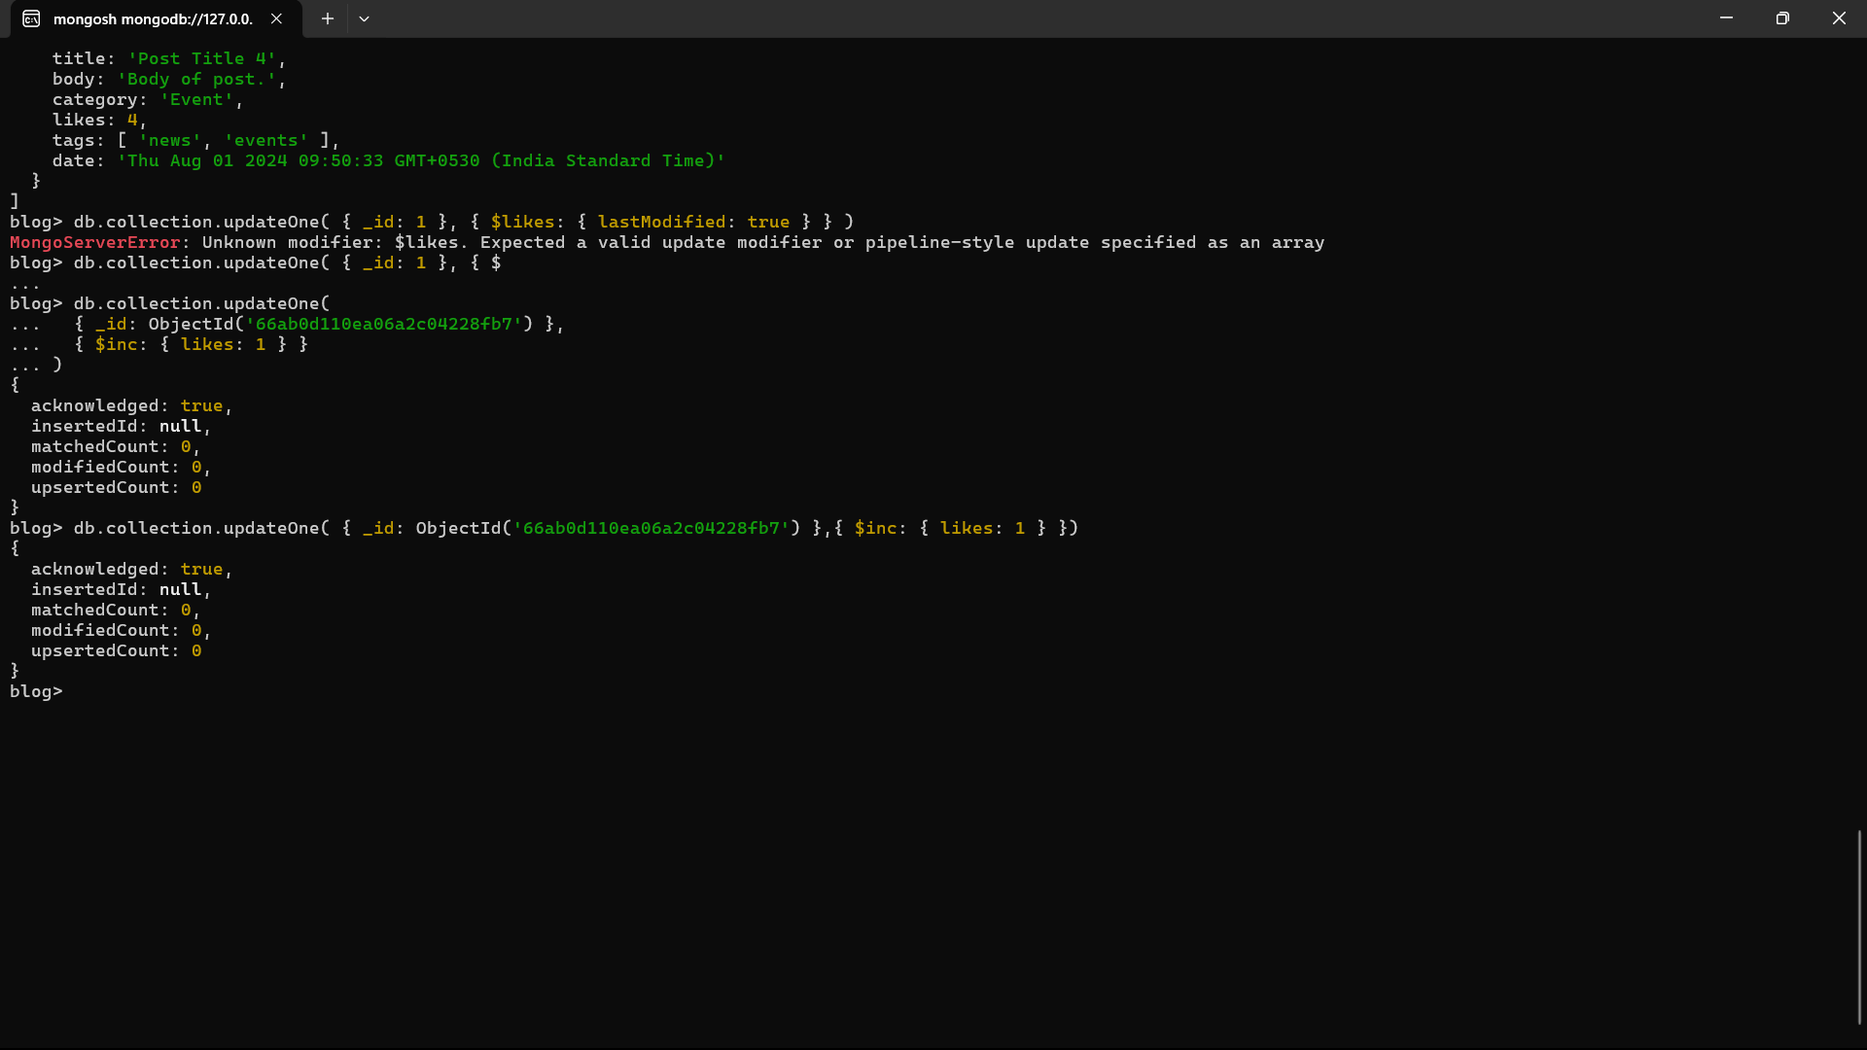

## **ARRAY:**

* $addToSet: Adds distinct elements to an array
* $pop: Removes the first or last element of an array
* $pull: Removes all elements from an array that match the query
* $push: Adds an element to an array

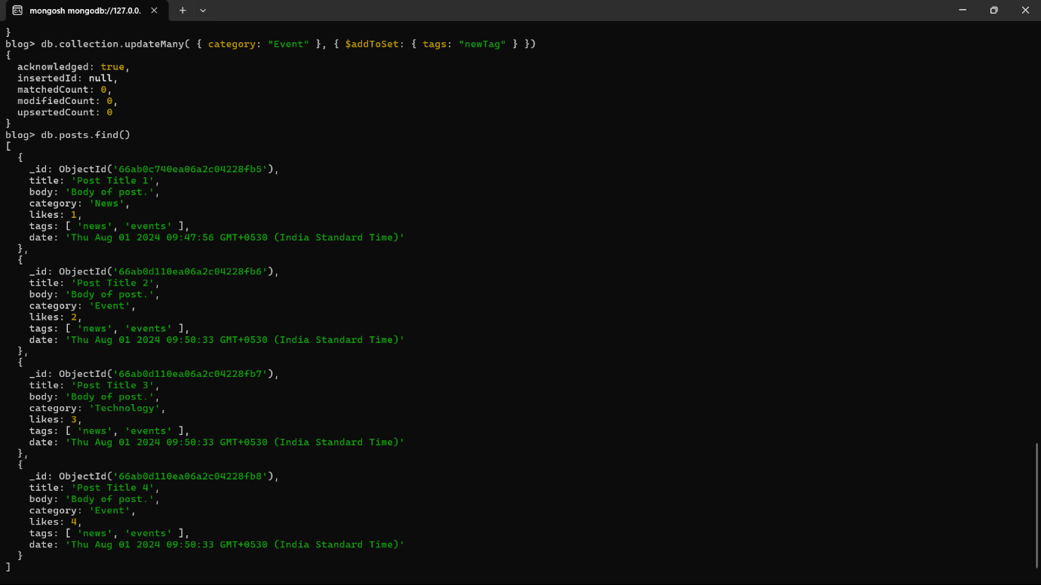

**MODIFIERS:**

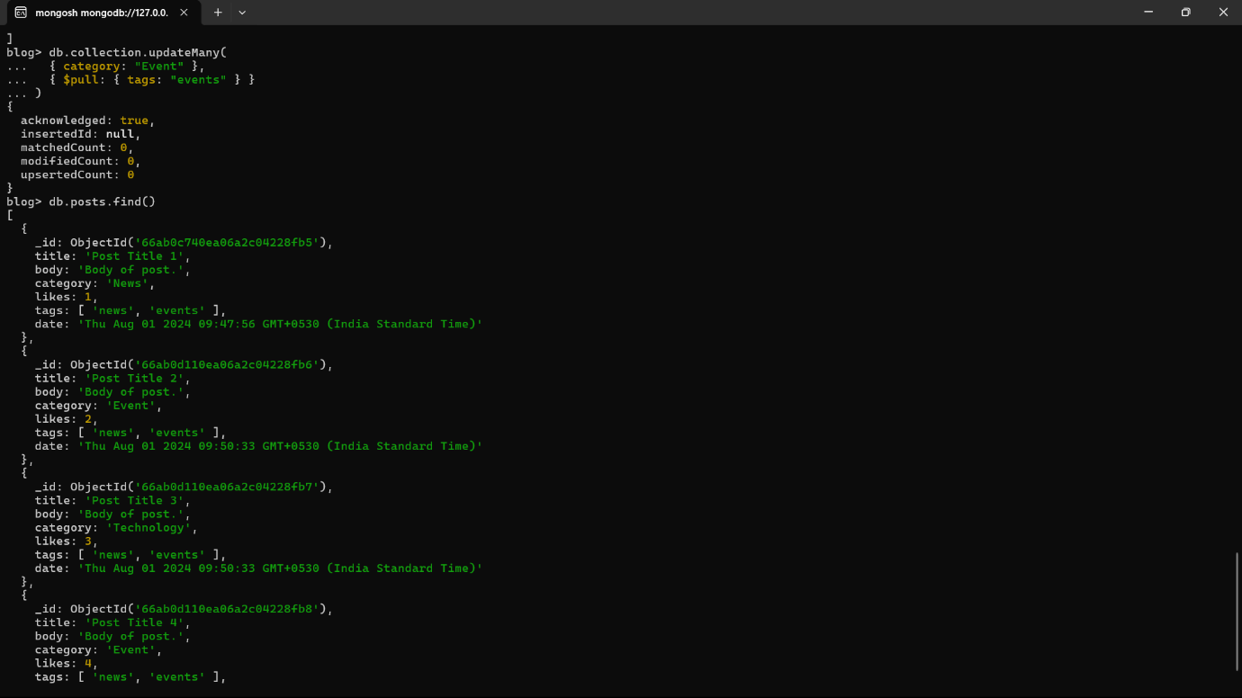

**$PULL**

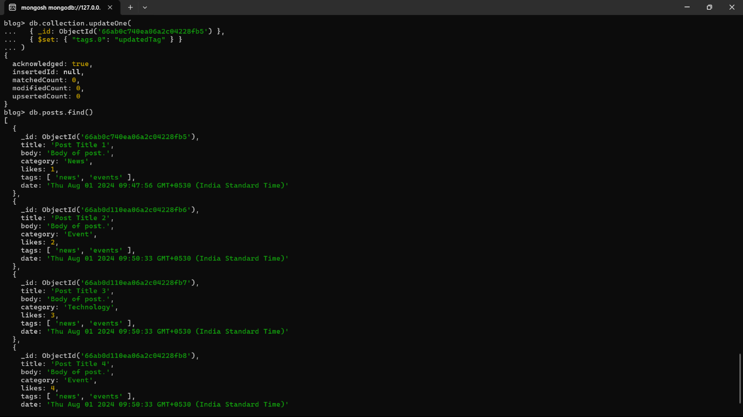

**$SET**

**BITWISE:**

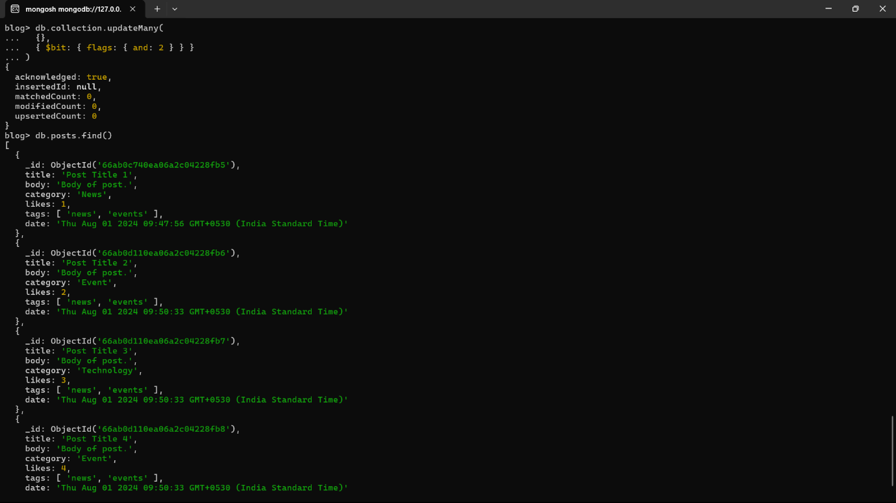

**$BIT**